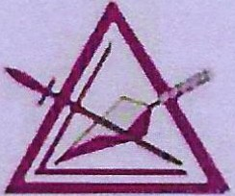

In anticipation of Illustrious Companion

**David A. Mourer**

Being elected and installed as the Most Illustrious Grand Master Of the Royal and Select Masons of Ohio .

The Companions and Ladies of the 9th Arch Association

Invite you to a reception in his honor On **Saturday, November 18, 2017** at the

**Southgate Hotel 2218 Southgate Parkway Cambridge, OH 43725**

Social Hour: 5:15-6:15 Entrance of Grand Officers at 6:15 Dinner at 6:30 Cost of Dinner is $30.00 per person

Dinners will consist of beef and chicken, sides, salad, rolls, dessert, coffee, ice tea Please complete the ticket order form and make your check payable to the **9th Arch**

**Association** and mail to *John RushJ 61865 Cabin Hill RoadJ New Concord/ OH 43762*

**Deadline for reservations is November 3, 2017**

A block of rooms are being held at the hotel at a group rate of $55.00 plus tax. Room reservations should be called in directly to the hotel at 740-432-7313. Please say use that you are with the "Grand Council". Cancellations must be received no later than 6:00 p.m. on your arrival date.

Please print for accuracy.

Dinner cost is $30 per person

Comp----------------Council---------No.---

Title Lady: _

Address---------------------Phone------

City State Zip _

Email --------------------------------

Number of meals

Beef & Chicken @ $30

Vegetarian@ $30 Enclosed: $ _

**Make checks payable to: 9th Arch Association, Mail to** *John Rush 61685 Cabin Hill Road, New Concord, OH 43762*

Will be reserving a room for the following night/s Friday Saturday